1. JTable.

It is a class that allows us to represent a table in a window. For this we need to previously create the headers and the data that will be inside the table. For the headers a String vector will suffice and for the data it is necessary to create a DefaultTableModel in a similar way to how we created the DefaultModel for the JLists:

// Headers for the columns of the table
String [] headers = new String []
{
"Name", "Address", "Telephone", "Car?"
};

// Data for the table
Object [] [] data = new Object [] []
{
{"Alfons González Pi", "Argentona, Barcelona", new Long (933333333), true},
{"Ana María Cuesta Suñer", "Gijón, Asturias", new Long (984454545), false},
{"Elena Veiguela Suárez", "Pontevedra", new Long (986678678), false},
{"Pedro Aguado Rodríguez", "Madrid", new Long (912804574), true}
};

Once we have the data we can instantiate the table. But in addition to instantiating the table, it must communicate to the JTable what its data model is and, at least, overwrite the getColumnClass method:

jTable1 = new JTable ();
jTable1.setModel (new DefaultTableModel (data, headers)
{
// Types of each column
Class [] tipoColumn = {String.class,
String.class,
Long.class,
Boolean.class};
// override the getColumnClass method
@Override
public Class getColumnClass (int indColum)
{
return Columntype [indColum];
}
});

Also JTable, like JList, need a scroll:

jScrollPanel1 = new JScrollPane (jTable1);

Now we can put the JScrollPanel in our window.

If we execute we would have a window like this:

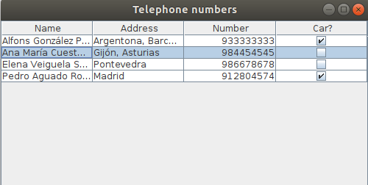

2. Get the data from a MySQL table.

For this example, let's take the clients table of the di database that we have already used on other occasions. The clients table has only two columns: id and notes
To obtain the data in this table, you must set the headers and the data that will be in each row. We are going to proceed differently than we did in point one. We will use the setColumnIdentifiers methods for the headers and addRow for each of the columns. Assuming we have instantiated a DefaultDataModel called model:

- Create the headers

// configuration columns of the DefaultTableModel
Object [] tags = new Object [2];
tags [0] = "Id";
tags [1] = "Notes";
model.setColumnIdentifiers (labels);

- Add rows from MySQL table

// connection to the database
String urlOdbc = "jdbc: mysql: // localhost: 3306 / di";
Connection with = // be careful with MySQL username and password
(java.sql.DriverManager.getConnection (urlOdbc, "root", ""));
// We prepare the query
Statement s = con.createStatement ();
ResultSet rs = s.executeQuery ("select * from clients");
// We go through the result, while there are records to read
// add each record to the DefaultDataModel
int rowNumber = 0;
while (rs.next ())
{
// The row for the table model is created and filled.
Object [] rowData = new Object [model.getColumnCount ()];
rowData [0] = rs.getObject (1);
rowData [1] = rs.getObject (2);
model.addRow (rowData);
rowNumber ++;
}
// We close the connection to the database.
rs.close ();
s.close ();
con.close ();

In this case, the data from the clients table would be shown:

